**Stable, Unstable, and Marginal**

**Stable Systems.**

**Lab: 03**



Fall 2022

CSE-3L Control Systems

Submitted by: **Amir Suliman**

Registration No: **19PWCSE1805**

Class Section: **B**

“On my honor, as a student of the University of Engineering and Technology, I have neither given nor received unauthorized assistance on this academic work.”

Student Signature: ______________

Submitted to:

**Dr: Muniba Ashfaq**

November 9, 2022

Department of Computer Systems Engineering

University of Engineering and Technology, Peshawar

**Objectives:**

* To know what are poles.
* To know about stable, unstable, and marginal stable systems.

**Stable Systems:**

A system is said to be stable if for every bounded input the system produces bounded output. This system is also called a controlled system. The real parts of the roots are negative.

**Code:**

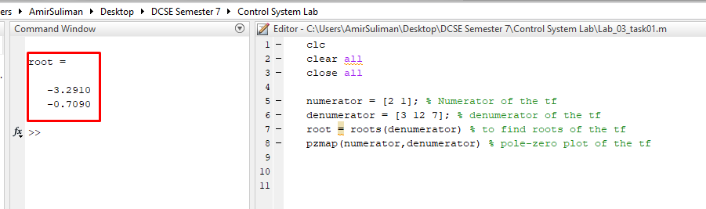

**Simulink:**

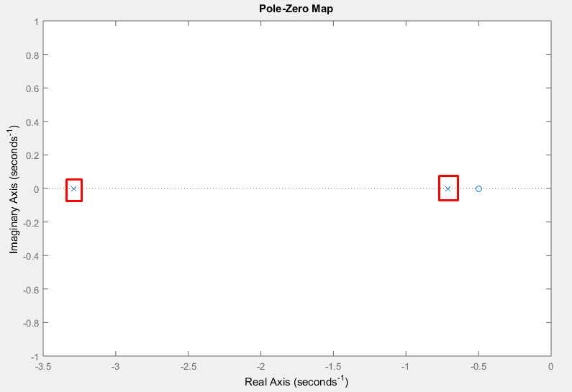

**Simulink:**

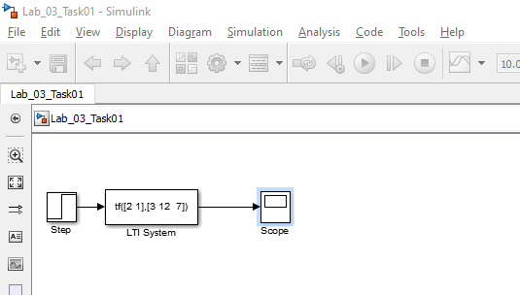

**Output:**

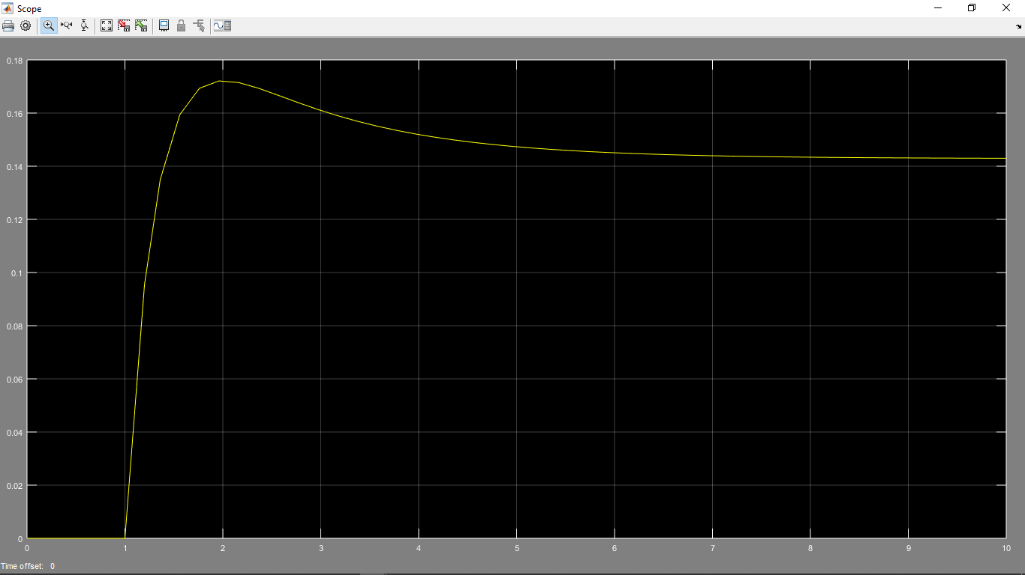

**Unstable Systems:**

The system is said to be unstable if any one pole is on the left side of the imaginary axis. That is one of the real roots that have a plus sign.

**Code:**

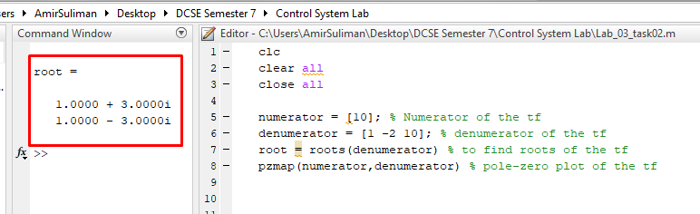

**Output:**

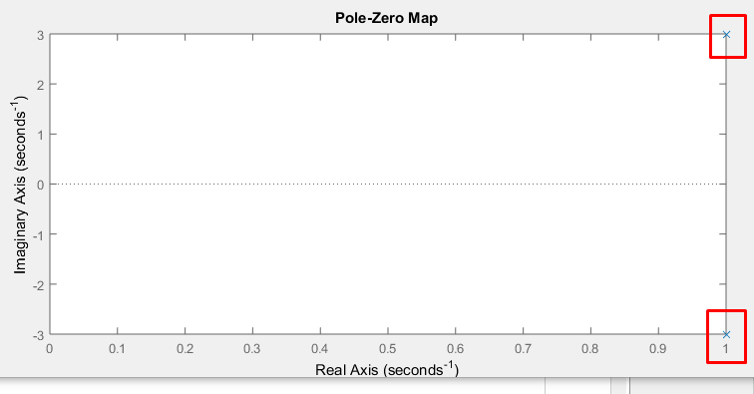

**Simulink:**

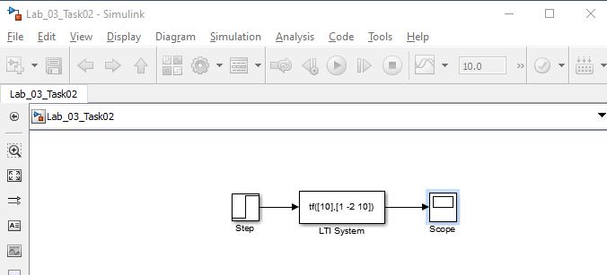

**Output:**

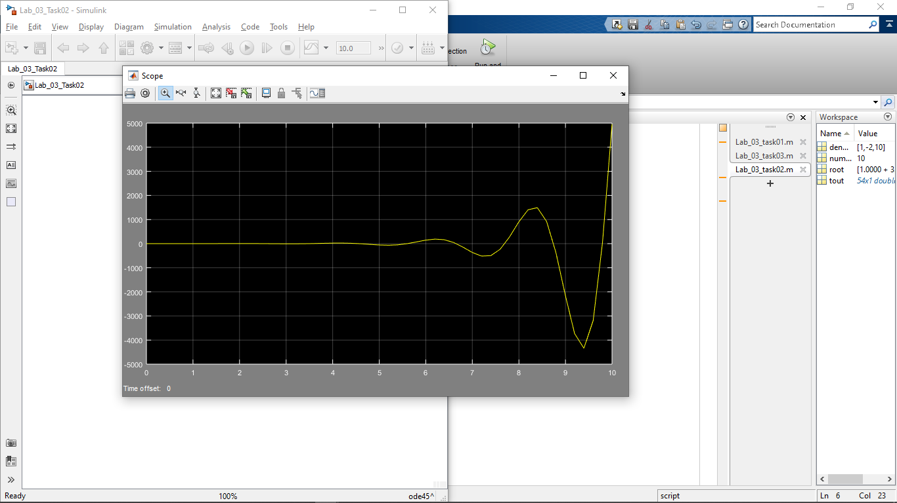

**Marginally Stable System:**

The system is said to be marginally stable If two poles of the open loop transfer function are present on the imaginary axis. That is the real part of the roots is zero.

**Code:**

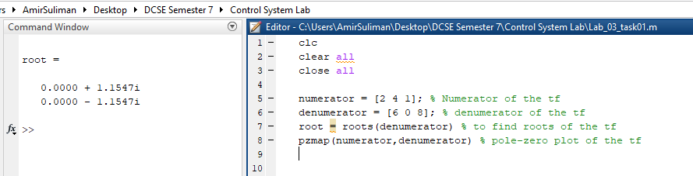

**Output:**

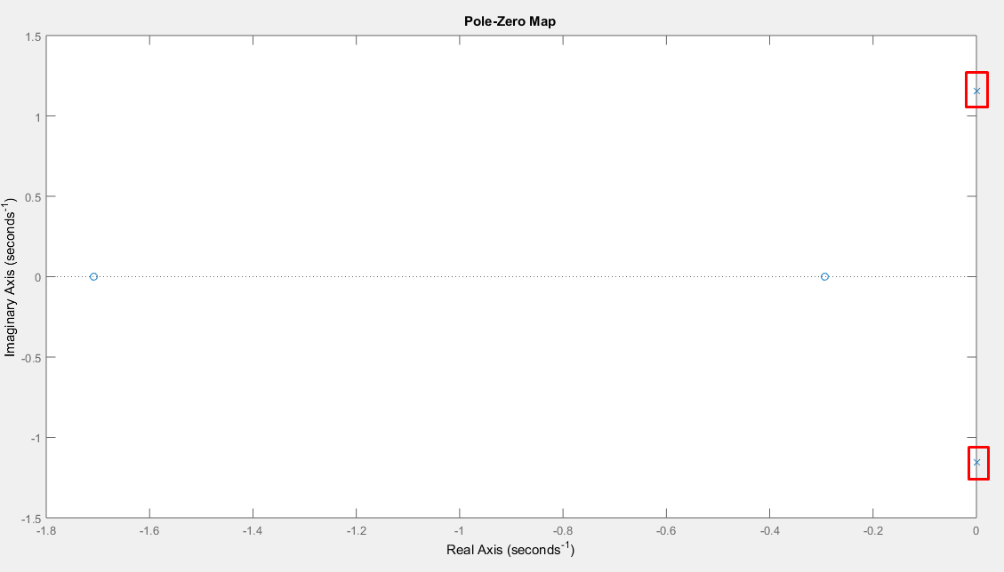

**Simulink:**

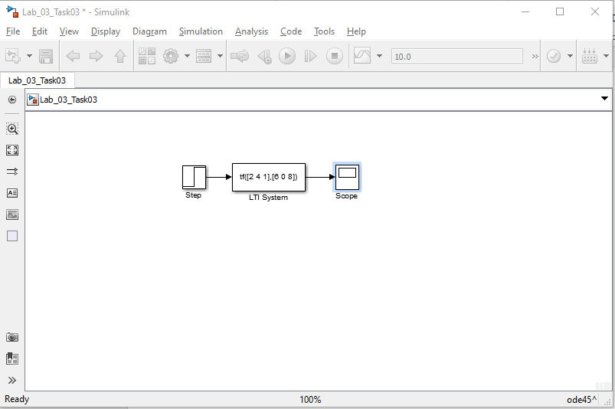

**Output:**

